Homework Assignment #6 - Inference for Categorical Data

6.1 Young Americans

About 25% of young Americans have delayed starting a family due to the continued economic slump.
📖 Demos.org. “The State of Young America: The Poll”. In: (2011).
Determine if the following statements are true or false, and explain your reasoning.
- The distribution of sample proportions of young Americans who have delayed starting a family due to the continued economic slump in random samples of size 12 is right skewed.
True. The success failure condition is not satisfied
ɳ𝑝=12x0.25 = 4 and ɳ(1-𝑝)=12x0.75=8
̭
Therefore, we know that the distribution of 𝑝 is not approximately normal.
Therefore, since 0.25 is closer to 0, the distribution would probably take on a right skewered shape.

- In order for the distribution of sample proportions of young Americans who have delayed starting a family due to the continued economic slump to be approximately normal, we need random samples where the sample size is at least 40.
True. Np is at least 10, and n(1-p) is at least 10 → success-failure condition Given p=0.25 $np=40x0.25=10$
$$n\left(1-p\right)=40x0.75=30$$
The minimum sample size that yields at least 10 successes and 10 failures can be calculated as
$$n=\max{(\frac{10}{0.25},\frac{10}{0.75})}=\left(40,13.3\right)=40$$
We need a sample of at least n=40 to meet the success failure condition.
- A random sample of 50 young Americans where 20% have delayed starting a family due to the continued economic slump would be considered unusual.
False. Standard error of p in samples with n= 50 can be calculated as
$$SEp=\frac{\sqrt{{p\left(1-p\right)}^{} }}{n}= \frac{\sqrt{{0.25x0.75}^{ }}}{50}=0.0612$$
A p of 0.20 is Z = 0.20-0.25 = -0.82 standard error away from the mean.
0.0612
This would not be considered unusual.

- A random sample of 150 young Americans where 20% have delayed starting a family due to the continued economic slump would be considered unusual.
False. Ap of 0.20 is Z = 0.20-0.25 = - 1.41 standard errors away from the mean
0.0354
This would not be considered unusual.
- Tripling the sample size will reduce the standard error of the sample proportion by one-third.
False. Doubling the sample size would decrease the standard error of the sample proportion only by a factor of $\sqrt{3}$

6.2 Is college worth it?

Among a simple random sample of 331 American adults who do not have a four-year college degree and are not currently enrolled in school, 48% said they decided not to go to college because they could not aﬀord school.
📖 Pew Research Center Publications, Is College Worth It?, data collected between March 15-29, 2011.
- A newspaper article states that only a minority of the Americans (less than 50%) who decide not to go to college do so because they cannot aﬀord it and uses the point estimate from this survey (48%) as evidence. Conduct a hypothesis test to determine if these data provide strong evidence supporting this statement.
50% of Americans who decide not to go to college because they cannot afford it is 50%.
H0:p=0.50
Less than 50% of Americans who decide not to go to college because they cannot afford it do so because they cannot afford it.
HA:p<0.50
Note that this is a one-side test.
The calculated test statistic zzz is approximately -0.73, and the p-value is 0.233.
- Would you expect a conﬁdence interval for the proportion of American adults who decide not to go to college because they cannot aﬀord it to include 0.5? Explain.
Yes, we would expect a confidence interval for the proportion of American adults who decide not to go to college because they cannot afford it to include 0.5. Here's why:
In the hypothesis test, our p-value was relatively high (0.233), indicating that we did not have enough evidence to reject the null hypothesis that the true proportion is 0.5. This suggests that 0.5 is a plausible value for the population proportion based on the sample data.
Since a confidence interval is designed to provide a range of plausible values for the true population proportion, and our sample proportion (48%) was close to 50%, a confidence interval—especially one with a 95% confidence level—would likely include 0.5. This aligns with the lack of strong evidence in our hypothesis test, further indicating that 0.5 is within the range of possible true proportions based on this data.

6.3 Prenatal vitamins and Autism

Researchers studying the link between prenatal vitamin use and autism surveyed the mothers of a random sample of children aged 24 - 60 months with autism and conducted another separate random sample for children with typical development.
📖 R.J. Schmidt et al. “Prenatal vitamins, one-carbon metabolism gene variants, and risk for autism”. In: Epidemiology 22.4 (2011), p. 476.
The table below shows the number of mothers in each group who did and did not use prenatal vitamins during the three months before pregnancy (periconceptional period).
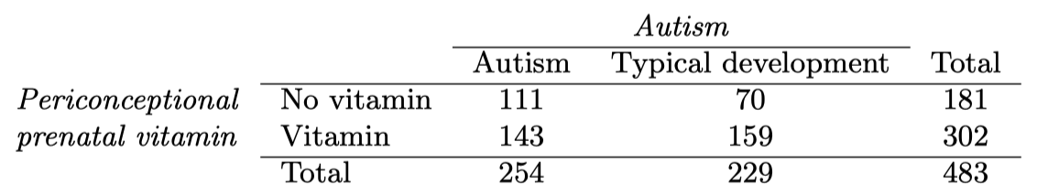
- State appropriate hypotheses to test for independence of use of prenatal vitamins during the three months before pregnancy and autism.
H₀:pv=pnv Prenatal vitamin use during the three months before pregnancy is independent of autism diagnosis. In other words, there is no association between prenatal vitamin use and autism.
H₀:pv≠pnv There is some difference
- Verify any necessary conditions for the test.
Independence of Observations: Each observation should be independent of others. In this context, this means that each mother-child pair is a unique case, with no overlap between groups. Since the data was collected through random sampling of mothers in each group (autism and typical development), we can reasonably assume that the independence condition The expected frequencies for each cell are as follows:
- Autism, No Vitamin: 95.18
- Autism, Vitamin: 158.82
- Typical Development, No Vitamin: 85.82
- Typical Development, Vitamin: 143.18
Since all expected frequencies are greater than 5, the expected frequency condition is met.
- Complete the hypothesis test and state an appropriate conclusion.
Since the observations are independent and the success-failure condition is met, it is expected to be approximately normal. Point estimate 0.47-0.61 = -0.14
- A New York Times article reporting on this study was titled “Prenatal Vitamins May Ward Oﬀ Autism”. Do you ﬁnd the title of this article to be appropriate? Explain your answer. Additionally, propose an alternative title.
📖 R.C. Rabin. “Patterns: Prenatal Vitamins May Ward Oﬀ Autism”. In: New York Times (2011).
The title "Prenatal Vitamins May Ward Off Autism" suggests a causal relationship between prenatal vitamin use and a reduced risk of autism. Observational studies cannot control for all possible confounding factors, so we cannot definitively say that taking prenatal vitamins "wards off" or prevents autism. The title could lead readers to believe that taking prenatal vitamins will actively prevent autism, which the study does not prove. A more suitable title could be Prenatal Vitamin Use Linked to Lower Risk of Autism in Observational Study.

6.4 Open source textbook

A professor using an open source introductory statistics book predicts that 60% of the students will purchase a hard copy of the book, 25% will print it out from the web, and 15% will read it online.
At the end of the semester he asks his students to complete a survey where they indicate what format of the book they used. Of the 126 students, 71 said they bought a hard copy of the book, 30 said they printed it out from the web, and 25 said they read it online.
- State the hypotheses for testing if the professor’s predictions were inaccurate.
We will use the chi-square: (H₀): The observed distribution of book format preferences among students matches the professor’s predicted distribution. In other words, there is no significant difference between the professor’s predictions and the actual distribution. (Hₐ): The observed distribution of book format preferences among students does not match the professor’s predicted distribution. In other words, there is a significant difference between the professor’s predictions and the actual distribution. If we find that the observed distribution differs significantly from the expected distribution (based on the professor's predictions), we would reject the null hypothesis, suggesting that the professor's predictions were inaccurate.
- How many students did the professor expect to buy the book, print the book, and read the book exclusively online?
Hard Copy (60%):
126×0.60=75.6≈76

Printed from Web (25%):
126×0.25=31.5≈32

Read Online (15%):
126×0.15=18.9≈19

- This is an appropriate setting for a chi-square test. List the conditions required for a test and verify they are satisﬁed.
Independence: Each case that contributes a count to the table must be independent of all other cases.
Sample is not random
Assuming that each student independently chose their preferred format, this condition is met.
Since all conditions are satisfied, a chi-square goodness-of-fit test is appropriate for this data set.

- Calculate the chi-squared statistic, the degrees of freedom associated with it, and the p-value.
The chi-squared statistic is approximately 2.32
The degrees of freedom are 2
The p-value is approximately 0.313

- Based on the p-value calculated in part (d), what is the conclusion of the hypothesis test? Interpret your conclusion in this context.
Since the p-value is greater than 0.05, we do not reject the null hypothesis. This indicates that there is no significant difference between the professor's predictions and the observed distribution of book format preferences among the students. ​

6.5 Offshore drilling

A survey asked 827 randomly sampled registered voters in California “Do you support? Or do you oppose? Drilling for oil and natural gas oﬀ the Coast of California? Or do you not know enough to say?” Below is the distribution of responses, separated based on whether or not the respondent graduated from college.
📖 Survey USA, Election Poll #16804, data collected July 8-11, 2010.
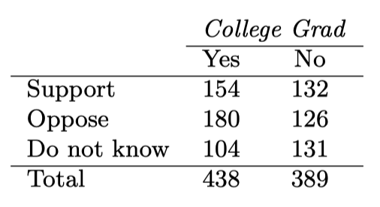
Complete a chi-square test for these data to check whether there is a statistically signiﬁcant diﬀerence in responses from college graduates and non-graduates.
Null Hypothesis (H₀): There is no association between college graduation status and opinion on drilling. In other words, opinion on drilling is independent of whether a respondent graduated from college.
Alternative Hypothesis (Hₐ): There is an association between college graduation status and opinion on drilling.
The results of the chi-square test are as follows: Chi-square statistic: 11.47 Degrees of freedom: 2 P-value: 0.003
Since the p-value is less than the common significance level of 0.05, we reject the null hypothesis. This indicates that there is a statistically significant difference in responses between college graduates and non-graduates regarding their opinion on drilling off the coast of California.

